III. Findings
This section presents the empirical findings of the study in two stages. First, the quantitative findings address RQ1 by examining how newly placed undergraduate students in EMI and TMI programmes in Türkiye differed across the 2023–2025 admission cycles in terms of gender, disability, and socioeconomic tier. Second, the qualitative findings will address RQ2 by exploring how students describe the role of these factors in shaping access to the two instructional tracks. At this stage, the focus remains on the quantitative profile of EMI and TMI.
3.1. Gender distribution across EMI and TMI
Table 1 presents the distribution of newly placed undergraduate students in EMI and TMI programmes by gender and disability across the 2023, 2024, and 2025 admission cycles. With regard to gender, a clear and stable contrast emerged between the two instructional tracks. Across all three years, EMI displayed a notably more balanced gender profile than TMI.
Table 1
Distribution of newly placed undergraduate students in EMI and TMI programmes by gender and disability, 2023–2025
Year | MOI | Total placed students | Female (n) | Female (%) | Male (n) | Male (%) | Disabled students (n) | Disabled (%)
2023 | EMI | 91,053 | 46,037 | 50.56 | 45,016 | 49.44 | 66 | 0.072
2023 | TMI | 427,274 | 251,868 | 58.95 | 175,406 | 41.05 | 446 | 0.104
2024 | EMI | 94,823 | 48,180 | 50.81 | 46,643 | 49.19 | 72 | 0.076
2024 | TMI | 451,681 | 267,385 | 59.20 | 184,296 | 40.80 | 460 | 0.102
2025 | EMI | 104,770 | 53,129 | 50.71 | 51,641 | 49.29 | 77 | 0.073
2025 | TMI | 492,179 | 289,549 | 58.83 | 202,630 | 41.17 | 476 | 0.097

In EMI, female students constituted 50.56% of newly placed students in 2023, 50.81% in 2024, and 50.71% in 2025. Male students accounted for 49.44%, 49.19%, and 49.29%, respectively. These figures indicate that EMI remained very close to gender parity throughout the three-year period and that its gender composition changed only minimally over time.
TMI, by contrast, displayed a more uneven gender distribution. Female students represented 58.95% of newly placed TMI students in 2023, 59.20% in 2024, and 58.83% in 2025, while male students accounted for 41.05%, 40.80%, and 41.17%, respectively. Thus, unlike EMI, TMI consistently showed a pronounced female majority across all three admission cycles.
In numerical terms, both EMI and TMI recorded growth in total student placements over time. EMI increased from 91,053 newly placed students in 2023 to 94,823 in 2024 and 104,770 in 2025. TMI similarly rose from 427,274 to 451,681 and then to 492,179. Despite this increase in overall placement volume, the gender profile of each instructional track remained remarkably stable. This suggests that the expansion of EMI and TMI during the 2023–2025 period did not substantially alter the gendered composition of either pathway.
Overall, the findings for RQ1a indicate that EMI and TMI differed consistently in terms of gender distribution. Whereas EMI maintained a near-equal balance between female and male students, TMI retained a clearly female-dominated profile across all three years.
3.2. Distribution of newly placed disabled students across EMI and TMI
The second part of RQ1 concerns the distribution of newly placed disabled students across EMI and TMI programmes. As shown in Table 1, newly placed disabled students represented a very small proportion of total placements in both instructional tracks. However, a consistent difference was observed between EMI and TMI across the three admission cycles.
In EMI, the proportion of newly placed disabled students was 0.072% in 2023, 0.076% in 2024, and 0.073% in 2025. The corresponding frequencies were 66, 72, and 77 students. Although these numbers increased slightly over time in absolute terms, the proportional representation of disabled students remained very low and largely stable.
In TMI, the proportion of newly placed disabled students was somewhat higher in all three years. Disabled students accounted for 0.104% of newly placed TMI students in 2023, 0.102% in 2024, and 0.097% in 2025, with frequencies of 446, 460, and 476, respectively. As in EMI, the absolute number rose modestly over time, but the proportional trend remained relatively consistent.
When the two instructional tracks are compared directly, TMI appears to have accommodated a slightly greater proportion of newly placed disabled students than EMI in each of the three admission cycles. While the difference is numerically small, it is nevertheless persistent. This continuity suggests that the lower representation of newly placed disabled students in EMI was not a temporary fluctuation but a recurring pattern throughout the period examined.
In response to RQ1b, the findings therefore suggest that disabled students constituted a very limited share of placements in both EMI and TMI, but that their proportional representation remained consistently lower in EMI than in TMI from 2023 to 2025.
3.3. Socioeconomic-tier distribution across EMI and TMI
The third part of RQ1 addresses the socioeconomic-tier distribution of newly placed students across EMI and TMI. The full numerical breakdown of tier-level placements is presented in Appendix A, while Figure 1 provides a visual summary of the distributional patterns. Provincial tier membership was determined according to the SEGE-2025 classification, and placement counts were interpreted alongside the aggregated 15–24 population of the provinces within each tier. This makes it possible to assess not only the absolute distribution of placements but also how that distribution relates to the candidate-age population base of each socioeconomic tier.
Figure 1
Distribution of newly placed EMI and TMI students across socioeconomic tiers in Türkiye, 2023–2025

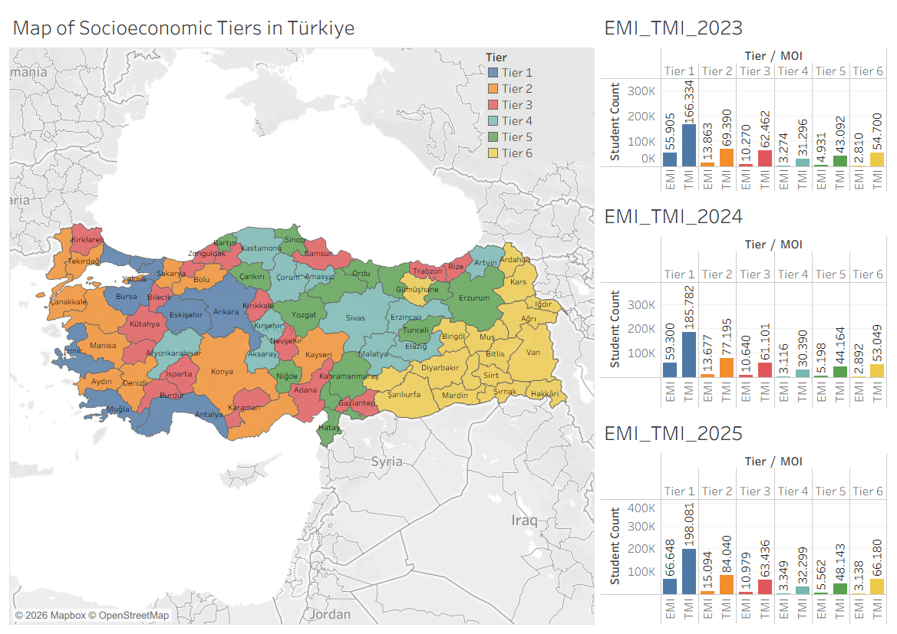
The socioeconomic findings reveal a marked contrast between EMI and TMI. Across all three years, EMI placements were heavily concentrated in Tier 1, the highest socioeconomic tier. In 2023, 55,905 of the 91,053 newly placed EMI students were located in Tier 1. This rose to 59,300 out of 94,823 in 2024 and 66,648 out of 104,770 in 2025. In broad terms, this means that around three-fifths of all newly placed EMI students were concentrated in the most socioeconomically developed tier throughout the period, and this concentration became slightly more pronounced over time.
TMI also recorded its highest number of placements in Tier 1, but its overall distribution was more dispersed across the tier structure. In 2023, Tier 1 accounted for 166,334 of 427,274 newly placed TMI students. In 2024, the figure rose to 185,782 of 451,681, and in 2025 it reached 198,081 of 492,179. Although Tier 1 remained the largest placement base for TMI, the degree of concentration was clearly lower than in EMI, indicating a broader spread across middle and lower tiers.
This contrast becomes more visible when the lower tiers are examined. In EMI, Tiers 5 and 6 consistently accounted for a relatively small portion of total placements. Tier 6, in particular, included only 2,810 EMI placements in 2023, 2,892 in 2024, and 3,138 in 2025. Even when the 15–24 population base is taken into account, EMI remained proportionally weakest in Tier 6, with rates of 0.14%, 0.15%, and 0.16%, respectively. TMI, by contrast, displayed far higher placement volumes in Tier 6, with 54,700 placements in 2023, 53,049 in 2024, and 66,180 in 2025.
A similar pattern is visible across the middle tiers. In EMI, placement rates generally declined from the highest to the lowest tiers. In 2025, for example, EMI accounted for 1.30% of the Tier 1 candidate-age population, compared with 0.74% in Tier 2, 0.65% in Tier 3, 0.45% in Tier 4, 0.49% in Tier 5, and only 0.16% in Tier 6. TMI also showed variation by tier, but the pattern was less sharply concentrated around Tier 1. Indeed, some lower or middle tiers displayed TMI placement rates comparable to or higher than those of Tier 1. In 2025, TMI accounted for 4.38% of the Tier 4 population and 4.23% of the Tier 5 population, compared with 3.86% in Tier 1.
Taken together, these results suggest that EMI was much more concentrated in the most socioeconomically developed tier, whereas TMI was distributed more broadly across the national tier structure. In other words, the social geography of EMI appears more selective and uneven than that of TMI. Although EMI was present in all tiers, its reach was considerably more limited in less developed tiers, both in absolute terms and relative to the 15–24 population base of those tiers.
The three-year comparison also points to continuity rather than major structural change. Across 2023, 2024, and 2025, the same broad hierarchy persisted: Tier 1 remained the principal location of EMI placements, while TMI continued to display a more dispersed profile across the six-tier structure. Thus, although the total number of placements increased in both EMI and TMI over time, the relative socioeconomic pattern remained largely stable.
In response to RQ1c, the findings indicate that newly placed EMI and TMI students were distributed across socioeconomic tiers in systematically different ways. EMI was disproportionately concentrated in the highest socioeconomic tier, whereas TMI showed a wider distribution across both higher and lower tiers.
3.4. Summary of quantitative findings
Overall, the quantitative findings reveal a consistent distinction between EMI and TMI in terms of student profile and distribution. EMI displayed a more gender-balanced intake, whereas TMI consistently showed a stronger female majority. Newly placed disabled students represented a very small proportion of both instructional tracks, yet their proportional presence remained lower in EMI than in TMI across all three years. Most notably, EMI placements were much more heavily concentrated in the highest socioeconomic tier, while TMI showed a broader distribution across the full tier structure.
Taken together, these findings suggest that EMI and TMI were not simply parallel instructional options with similar student compositions. Rather, they reflected different patterns of representation that are directly relevant to questions of equity, diversity, and inclusion in Turkish higher education

Appendix
Table 2
Distribution of newly placed undergraduate students in EMI and TMI programmes across socioeconomic tiers in Türkiye, 2023–2025
Year | Tier | Tier 15–24 population | EMI placements (n) | EMI as % of tier 15–24 population | TMI placements (n) | TMI as % of tier 15–24 population
2023 | 1 | 5,129,841 | 55,905 | 1.09 | 166,334 | 3.24
2023 | 2 | 2,035,794 | 13,863 | 0.68 | 69,390 | 3.41
2023 | 3 | 1,697,368 | 10,270 | 0.61 | 62,462 | 3.68
2023 | 4 | 737,884 | 3,274 | 0.44 | 31,296 | 4.24
2023 | 5 | 1,138,332 | 4,931 | 0.43 | 43,092 | 3.79
2023 | 6 | 1,969,129 | 2,810 | 0.14 | 54,700 | 2.78
2024 | 1 | 5,129,841 | 59,300 | 1.16 | 185,782 | 3.62
2024 | 2 | 2,035,794 | 13,677 | 0.67 | 77,195 | 3.79
2024 | 3 | 1,697,368 | 10,640 | 0.63 | 61,101 | 3.60
2024 | 4 | 737,884 | 3,116 | 0.42 | 30,390 | 4.12
2024 | 5 | 1,138,332 | 5,198 | 0.46 | 44,164 | 3.88
2024 | 6 | 1,969,129 | 2,892 | 0.15 | 53,049 | 2.69
2025 | 1 | 5,129,841 | 66,648 | 1.30 | 198,081 | 3.86
2025 | 2 | 2,035,794 | 15,094 | 0.74 | 84,040 | 4.13
2025 | 3 | 1,697,368 | 10,979 | 0.65 | 63,436 | 3.74
2025 | 4 | 737,884 | 3,349 | 0.45 | 32,299 | 4.38
2025 | 5 | 1,138,332 | 5,562 | 0.49 | 48,143 | 4.23
2025 | 6 | 1,969,129 | 3,138 | 0.16 | 66,180 | 3.36

